|  |
| --- |
| C:\Users\student\Desktop\Asia_Pacific_College_Logo.png |
| TEST PLAN |
| Resources for the Blind – Inventory System |
|  |
|  |
|  |

**Clarence Carillaga**

**Pauline Gabrielle De Ocampo**

**Phil Harvey Burgos**

**March 2015**

|  |
| --- |
|  |

Table of Contents

[**I.** **BACKGROUND** 3](#_Toc413783756)

[**III.** **ASSUMPTIONS** 4](#_Toc413783759)

[**IV.** **TEST ITEMS** 5](#_Toc413783760)

[**V.** **FEATURES TO BE TESTED** 5](#_Toc413783761)

[**VI.** **FEATURES NOT TO BE TESTED** 6](#_Toc413783762)

[**VII.** **APPROACH** 6](#_Toc413783763)

[**VIII.** **ITEM PASS/FAIL CRITERIA** 6](#_Toc413783764)

[**IX.** **SUPENSION/RESUMPTION CRITERIA** 7](#_Toc413783765)

[**X.** **TEST DELIVERABLES** 8](#_Toc413783768)

[**XI.** **TESTING TASKS** 8](#_Toc413783769)

[**XII.** **ENVIRONMENTAL NEEDS** 8](#_Toc413783770)

[**XIII.** **RESPONSIBILITIES** 9](#_Toc413783774)

[**XIV.** **STAFFING & TRAINING** 9](#_Toc413783775)

[**XV.** **SCHEDULE** 9](#_Toc413783776)

[**XVI.** **RESOURCES** 10](#_Toc413783777)

[**XVII.** **RISKS & CONTINGENCIES** 10](#_Toc413783778)

[**XVIII.** **APPROVALS** 11](#_Toc413783779)

# **BACKGROUND**

## Company Profile



Resources for the Blind Inc. is a non-profit and non-government Christian organization that serves the visually-impaired people since 1988. They devoted themselves in removing the obstacles and providing services, trainings, and equipment needed in order for those who are visually-impaired to reach their fullest potential in life.

**Mission**

To design and implement programs that will enable those with visual impairment to understand and reach their God-given potential in life and service.

**Vision**

All Filipinos who are visually impaired will be able to reach their fullest potential in life and in ministry that God has for them.

1. **INTRODUCTION**

The Resources for the Blind – Inventory system was formerly created using the Yii 1.1 framework, and will now be adapted using the latest framework of Yii, which is Yii 2.0. The new system will have to meet the expected functions of the system listed below as well as its main objective of being able to administer a visually-impaired friendly system.

**Vision:**

To be able to create an Inventory System that will monitor Resources for the Blind's daily transactions and provide a visually-impaired friendly interface.

**Expected functions of the system (Scope):**

*Item Records*

* Shows products
* Shows the product information *(details about the product, such as, name, description, price, quantity, etc.)*
* Admin can add, modify and delete product information

*User Information*

* Show customer information *(personal details about the customer, such as, customer name, address, contact, etc.)*
* Show supplier information *(personal details about the supplier, such as, supplier name, address, contact, etc.)*
* The admin can add, modify, and delete customer information
* The admin can add, modify, and delete supplier information

*Transaction Module*

* Shows the daily, monthly, and annual transactions
* Generate a report on the daily, monthly and annual transactions

The system will be visually-impaired friendly. Its interface will easily be manipulated; controls will mostly be composed of tab keys, arrow keys and buttons with labels.

## Testing Strategy

* Static Testing – is a form of software testing where the actual program or application is not used. This method involves examination of the program’s code and its associated documentation but does not require the program be executed.
* Dynamic Testing – this method involves interaction with the program while it runs. It assesses the feasibility of a software program by giving input and examining the output (I/O). It requires that the code be compiled and run.

# **ASSUMPTIONS**

The system would go through three types of testing:

* Static testing – documentation and code review
* Dynamic Testing – quality checking of the system
* User Acceptance Testing – users evaluation

The following conditions must be met before the testing phase:

* For static testing, the required documentation must be finished
* For dynamic testing, the system should have passed the code review and the modules are set and completed
* For UAT, the system should have passed both static and dynamic testing (QA Testing)

The issues found during testing should be logged (using the Issue Log) and all change requests (minimal or not) should be documented.

# **TEST ITEMS**

|  |  |
| --- | --- |
| MODULES | DESCRIPTION |
| Product Records | This module shows the products of the Resources for the Blind including its information. The admin can also add, modify and delete the information about the product. |
| User Information | This module is divided into two parts: Customer Information and Supplier Information. It shows the information about the customer and supplier. The admin can add, modify, and delete the information about the customer and supplier. |
| Order | This module shows the orders of the customers, including its information. The admin can add, modify, and delete the information about the order. |
| Transactions | This module shows the daily, monthly, and annual transactions of Resources for the Blind. The admin can also generate a report based on the daily, monthly and annual transactions. |

# **FEATURES TO BE TESTED**

|  |  |  |
| --- | --- | --- |
| FEATURE | DESCRIPTION | PRIORITY |
| User Login | Username and password for user log in (Admin only) | Normal |
| Index Page | The main page of the Inventory system once the admin is logged in | High |
| Customer Page | The customers’ information page | High |
| Contact Persons Page | The customer contact / contact persons page | Normal |
| Suppliers Page | The suppliers’ information page | High |
| Product Inventory Page | The products’ information page | High |
| Orders Page | The orders’ information page | High |
| Transactions Page | The page where the admin can generate the transaction reports | High  *Not yet available in the system* |
| Accessibility | Black screen and text-to-speech | High  *Will be tested after the Inventory system is completed* |

# **FEATURES NOT TO BE TESTED**

|  |  |  |
| --- | --- | --- |
| FEATURE | DESCRIPTION | PRIORITY |
| User Interface | The graphical design interface of the whole system (every module and page) of Resources for the Blind | Low |

# **APPROACH**

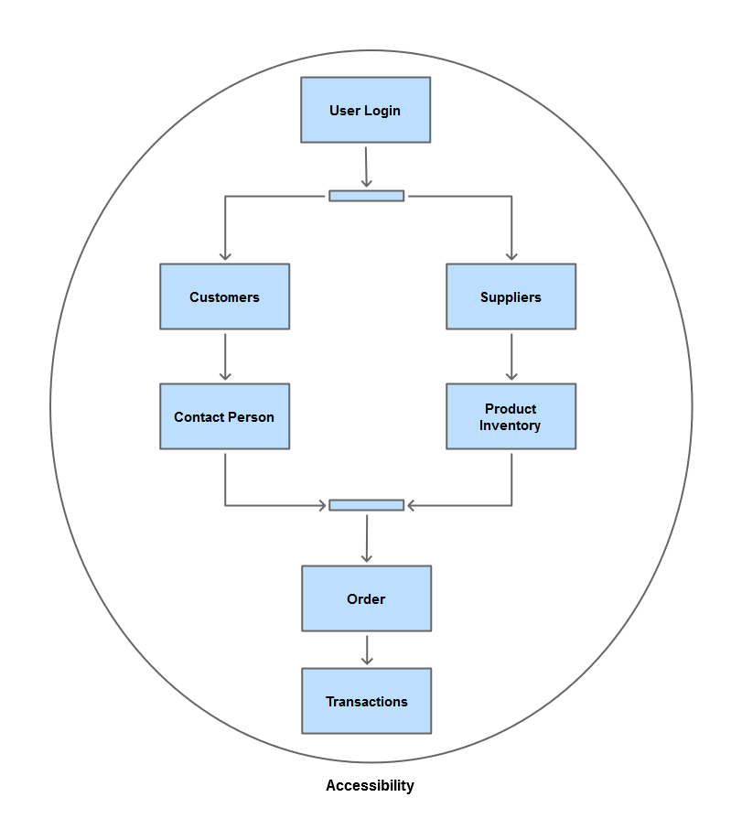

For the system testing, it will start from the Login module then to the Index page. Afterwards, they can proceed testing either the Customer page or Supplier page. The Customers feature has to precede the testing of the Contact Persons while the Supplier feature will precede the Product Inventory feature. After testing all the said features, they can proceed testing with the Order page (which is related to the Customer and Product Inventory features) and this will be tested before the Transactions module, or report generation module.

To meet the goal of being a visually-impaired friendly system, it will have to meet the requirements of being accessible and this will be included for all features.

# **ITEM PASS/FAIL CRITERIA**

|  |  |  |
| --- | --- | --- |
| FEATURE TO BE TESTED | APPROVAL / PASS CRITERIA | FAIL CRITERIA |
| User Login | The admin must be able to log in using the system | The admin credentials are not accepted by the system |
| Index Page | After the admin has logged in, he/she can access the index page where the summary of the link pages below can be found | The admin won’t be able to:   * Redirected to the index page * See the link pages |
| Customer Page | The admin can be redirected to this page, and he/she will be able to view the customers’ information and add, modify, and delete the information | The admin won’t be able to:   * View the customer information * Add customer information * Edit customer information * Delete customer information |
| Contact Persons Page | The admin can be redirected to this page, and he/she will be able to view the contact persons’ information and add, modify, and delete the information | The admin won’t be able to:   * View the contact person information * Add contact person information * Edit contact person information * Delete contact information |
| Suppliers Page | The admin can be redirected to this page, and he/she will be able to view the suppliers’ information and add, modify, and delete the information | The admin won’t be able to:   * View the supplier information * Add supplier information * Edit supplier information * Delete supplier information |
| Product Inventory Page | The admin can be redirected to this page, and he/she will be able to view the products’ information and add, modify, and delete the information | The admin won’t be able to:   * View the product inventory page * Add product information * Edit product information * Delete product information |
| Orders Page | The admin can be redirected to this page, and he/she will be able to view the orders’ information and add, modify, and delete the information | The admin won’t be able to:   * View the order information * Add order information * Edit order information * Delete order information |
| Transactions Page | The admin can be redirected to this page, and he/she will be able to view the transactions and generate a report based on the daily, monthly and annual transactions | The admin won’t be able to:   * View the daily, monthly and annual transactions * Generate a report based on the daily, monthly, annual transactions |
| Accessibility | The admin can “read” the system by using the screenreader | The admin won’t be able to:   * Hear the Inventory system using the text-to-speech system |

# **SUPENSION/RESUMPTION CRITERIA**

## SUSPENSION CRITERIA

System testing will be suspended when:

* Exception handlings on input of data
* Related module is not yet done when about to be tested
* Requirements are still not done
* Possible bugs that can hinder the testing process

## RESUMPTION CRITERIA

System testing will resume when:

* Modules are completed
* Requirements are completed
* Bugs and errors are fixed

# **TEST DELIVERABLES**

* Test Plan
* Test Cases
* Test Reports
* Test Summary Report
* Test Input / Output Data
* Release Notes

# **TESTING TASKS**

|  |  |
| --- | --- |
| TASK | DESCRIPTION |
| Provide test plan | Given to have a concept of the test workflow |
| Create test cases | These test cases should be provided in order to know the procedures to be followed for testing the system |
| Create test report and test summary report | Document the results based on the module / feature testing |
| Create test summary Report | Provide a summary report from the overall system testing |
| Test Execution | Execute test cases |

# **ENVIRONMENTAL NEEDS**

## Hardware

* PC/Laptop
* Internet Connection
* Android Device

## Software

* Browser
* XAMPP for local testing
* PHPmyadmin for local testing
* NVDA or JAWS

## Documents

* Software Quality Assurance Plan
* Test Documents (Test Plan, Test Cases)

# **RESPONSIBILITIES**

|  |  |
| --- | --- |
| ROLE | RESPONSIBILITIES |
| Developers | Prepares the system for testing and the test cases for the testers |
| Data Administration Staff | Manages and evaluates the database before the test execution proper |
| Testers | Executes the testing of the system |
| Users | Accepts and uses the system after testing |

# **STAFFING & TRAINING**

The testers and the users have to be familiar with the system and the business processes.

* Documentation – They will be given the documentation (SQAP, User manual, Test Plan) to have a background of the business processes, modules and workflow of the system they are about to use / test.
* System Demo – A brief demonstration about the system to get to know the modules and its functions and interface better.
* Assessment of the Testers – the knowledge and skills of the testers will be evaluated to check if they are fit to test the system

# **SCHEDULE**

|  |  |  |
| --- | --- | --- |
| TESTING TASK | START DATE | END DATE |
| Static Testing Round 1 (SQAP) | February 12, 2015 | February 15, 2015 |
| Static Testing Round 1 – Results | February 16, 2015 | February 16, 2015 |
| Static Testing Round 2 (Test Plan & Test Cases) | March 11, 2015 | March 11, 2015 |
| Static Testing Round 2 - Results | March 16, 2015 | March 16, 2015 |
| Dynamic Testing (System) | March 30, 2015 | March 30, 2015 |
| Dynamic Testing - Results | March 30, 2015 | March 30, 2015 |

# **RESOURCES**

|  |  |
| --- | --- |
| RESOURCE | LINK |
| Test Plan and Test Cases | https://code.google.com/p/apc-softdev-it111-06/source/browse/#git%2Fdocumentation%2Fquality%2FTest%20Documents |
| Project Documentation | http://projects2.apc.edu.ph/wiki/index.php/QUALITY\_IT111\_Resources\_For\_The\_Blind\_Inventory\_System\_-\_SQAP |
| Project Repository | https://code.google.com/p/apc-softdev-it111-06/ |
| Website | ---- |

# **RISKS & CONTINGENCIES**

|  |  |  |  |
| --- | --- | --- | --- |
| RISK | DESCRIPTION | IMPACT | CONTINGENCIES |
| Incorrect Input of Data | This risk happens when a user inputs incorrect data. This can affect the data stored in the database. | Low | Provide proper labeling of text fields in forms to fill out and for multiple options, a dropdown list may be given. |
| Non-availability of required hardware / software / tools | This risk happens when a hardware / software / tool is needed during testing but is not available | High | Install needed software / tools and have required hardware.  Provide a back up equipment / hardware which has an installed software / tool to be used. |
| Changes to the original requirements / designs | This risk happens when changes to the requirements has not been noted. | High | Document all and any changes with regard to requirements and designs of the system.  Explain the changes to the assigned testers and update the affected documentation of the module / feature / document to be tested for their reference. |
| Untrained professional | This risk happens when the personnel in charge is not trained beforehand. | Medium | Train professionals.  Provide assistance to the personnel or have another assigned skilled professional to take over the tasks |
| Inaccessible modules / pages | This risk happens when there is an error coming from the server side, possibly due to programming / database / network errors. | High | System must be quality checked and evaluated beforehand. |

# **APPROVALS**

The Resources for the Blind, Inc – Inventory System test plan has been reviewed and acknowledged. Any changes to this test plan are subjected for further approval.

Name and Signature:

Title:

Date of Approval:

Name and Signature:

Title:

Date of Approval:

Name and Signature:

Title:

Date of Approval: